Title of the Event | Outbound Training | 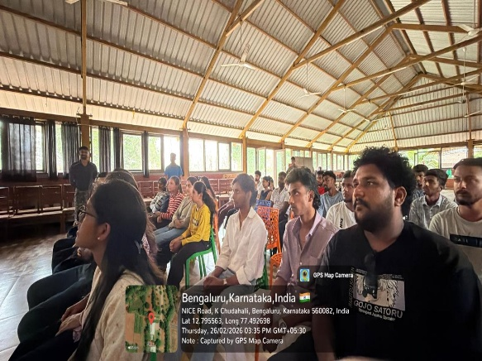
Day and Date | 26-27 February 2026
Venue (With all details ) | Eagle Unbound, kanakpura, banaglore
In collaboration with ( if any) | Business Management Department
Details of Resource Person With Designation | Mr.Manoj | 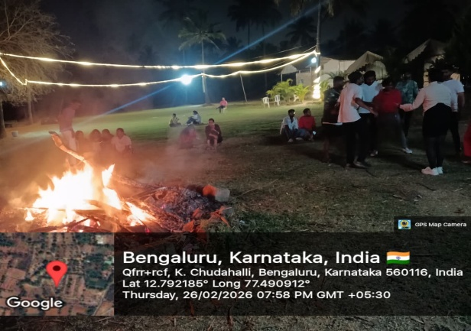
Organizing Department/Coordinators | Business Management ,
Course and semester | MBA I ,III Sem
No of Students & Faculty Participants | 39

Coordinator HoD Vice-Principal Principal

Introduction
The MBA Department organized a two-day outbound training program at Eagle Unbound, Kanakapura on 26th and 27th February 2025. The program was designed to enhance team bonding, leadership skills, and resilience among students through experiential learning in an outdoor environment. The coordinators for the activity were Preethi Ma’am, Rakshitha Ma’am, and Dr. Praveen Sinha.
Description of the Activity
The training comprised a blend of fun-filled activities, team-building games, and military-style training modules. Students actively participated in obstacle courses, trust-building exercises, and collaborative challenges that encouraged strategic thinking and effective communication.
The campsite stay in tents offered a unique experience of community living and adaptability. Students enjoyed a lively rain dance, a vibrant campfire session with music and reflections, and shared meals including breakfast, lunch, and dinner prepared at the venue. The overall program combined adventure with structured learning, making it both enjoyable and impactful.
Outcome of the Activity
The outbound training helped students step out of their comfort zones and discover their leadership potential. It strengthened team bonding, improved communication skills, and fostered resilience in challenging situations. Students developed confidence in collaborative problem-solving and built lasting connections with their peers. The program successfully integrated experiential learning with fun, leaving participants with valuable lessons and memorable experiences.
Conclusion
The outbound training program at Eagle Unbound was a highly effective initiative by the MBA Department. It provided students with opportunities to learn leadership, teamwork, and adaptability in a practical outdoor setting. The combination of structured activities and recreational experiences ensured holistic development. Coordinated by Preethi Ma’am, Rakshitha Ma’am, and Dr. Praveen Kumar Sinha, the program achieved its objectives of enhancing student skills while creating lasting memories.

